AI blognest - generate high-quality blog content using AI
TEAM MEMBERS:
Malar V malar30velsamy@gmail.com
Kasthuri P kasthuripanneerselvam08@gmail.com
Durga Devi R durgadevir301106@gmail.com
Abinaya R abinayaanu1922@gmail.com
1. INTRODUCTION
AI BlogNest is an AI-powered blog content management system designed to simplify blog creation, content management, and intelligent writing assistance. The system combines traditional blogging features with Generative AI so that users can create high-quality content with less manual effort.
The backend is developed using Node.js and Express.js. MongoDB is used as the primary database with Mongoose ODM for data modeling, validation, and database interaction. Google Gemini AI is integrated to provide AI-assisted blog generation and content summarization.
The application also includes secure authentication, role-based access control, blog management, categories and tags, comment management, media information, search capabilities, input validation, sanitization, rate limiting, and centralized error handling.

2. EXISTING SYSTEM
In a traditional blogging workflow, authors manually prepare blog content, organize drafts, manage categories and tags, and handle publication activities. When multiple tools are used for writing, storage, moderation, and publishing, the workflow can become difficult to manage.
- Manual blog content creation takes more time.
- Managing multiple drafts and categories can be difficult.
- Content approval and comment moderation may require separate processes.
- There is limited intelligent assistance for generating or summarizing content.
- Different user permissions may not be centrally managed.

3. PROPOSED SYSTEM

AI BlogNest provides a centralized backend platform for blog creation and content management. It combines REST APIs, MongoDB, role-based security, and Generative AI services in a modular architecture.
- AI-assisted blog content generation from a topic or prompt.
- AI-powered summarization of existing blog content.
- Secure JWT-based authentication.
- Role-based access for Admin, Editor, Author, and Reader.
- CRUD operations for blog posts.
- Category, tag, comment, and media management.
- Input validation and sanitization.
- Centralized error handling and structured logging.

4. OBJECTIVES
- To develop a secure and scalable blog management backend.
- To reduce the time required to create blog content.
- To integrate Generative AI into the content creation workflow.
- To provide automatic blog summarization.
- To manage users using role-based permissions.
- To store blog and user data reliably using MongoDB.
- To provide REST APIs that can be tested and consumed by frontend applications.
5.SOFTWARE REQUIREMENTS

- Operating System: Windows 10/11, macOS, or Linux.
- Node.js: Version 16 or above.
- npm: Version 8 or above.
- Express.js: Backend REST API framework.
- MongoDB: NoSQL database.
- Mongoose: MongoDB ODM.
- Google Gemini AI: AI content generation and summarization.
- Postman or Thunder Client: API testing.
- Visual Studio Code: Development environment.
6. HARDWARE REQUIREMENTS
- Processor: Intel Core i5 8th Gen or above / AMD Ryzen 5 or equivalent.
- RAM: 8 GB minimum; 16 GB recommended.
- Storage: At least 1 GB available project workspace.
- Internet connection: Required for cloud database and AI service integration.
7.Development Environment

The project can be developed and tested using Visual Studio Code with Node.js and npm. MongoDB provides persistent data storage, while Postman can be used to verify REST API requests and responses.

8. SYSTEM ARCHITECTURE

- AI BlogNest follows a layered server architecture. Incoming API requests are received by the Express server, processed through authentication and validation middleware, passed to controllers and services, and finally stored or retrieved through the Mongoose database layer.
- API Interface: Postman or frontend clients communicate with REST endpoints.
- Express Server Gateway: Handles HTTP requests, JSON parsing, routes, and CORS.
- Authentication & Authorization Middleware: Validates JWT tokens and checks roles.
- Controller Layer: Processes requests and prepares API responses.
- Service Layer: Implements business rules and AI operations.
- Mongoose Database Layer: Communicates with MongoDB.
- AI Flow: Connects to Google Gemini AI for generation and summarization.

9.KEY FEATURES
- Role-Based Route Guarding: Unauthorized roles are prevented from accessing protected resources.
- CRUD Blog Execution: Supports creation, reading, updating and deletion of blog records.
- Categorization System: Categories and tags help organize and discover content.
- Comment Moderation: Comments can be managed through protected endpoints.
- Sanitization Safeguards: Input sanitization helps reduce malicious parameter and script risks.
- AI-Driven Blog Generation: High-level topics can be transformed into structured blog content.
- Intelligent Summarization: Long blog content can be converted into concise summaries.
- Authentication: JWT provides stateless user authentication.
- Password Security: bcrypt.js can be used for secure password hashing.
- Centralized Error Handling: Consistent error responses improve backend reliability.
9.1 Content Management
The platform allows authorized users to manage blog content while keeping role permissions separate. Authors focus on creation, Editors focus on review and publication workflows, and Administrators manage broader system functions.
10.ROLES AND RESPONSIBILITIES
10.1 Admin
The Admin has complete environment-level control. Administrative functions include user management, role assignment, comment management, system inspection and access to logging information.
10.2 Editor
The Editor focuses on editorial workflows. Editors can review pending posts, manage publication status and maintain category organization.
10.3 Author
The Author has restricted access for creating and managing posts associated with the author's account. Authors can prepare drafts and submit content for review.
10.4 Reader
The Reader is primarily a content consumer. Readers can access published material and create comments using an authenticated identity.
10.5 User Flow
Registration → Login → JWT Authentication → Role Verification → Blog Creation/Reading → AI Generation or Summarization → Save → Review/Publish → Reader Access → Comments.
11. PROJECT SETUP AND CONFIGURATION
11.1 Creating the Project
- Create a new folder with the project name AI BlogNest.
- Create a Server folder inside the project.
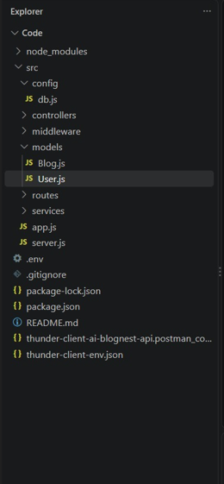
- Open the Server folder in Visual Studio Code.
- Open the terminal in VS Code.
- Run: npm init -y

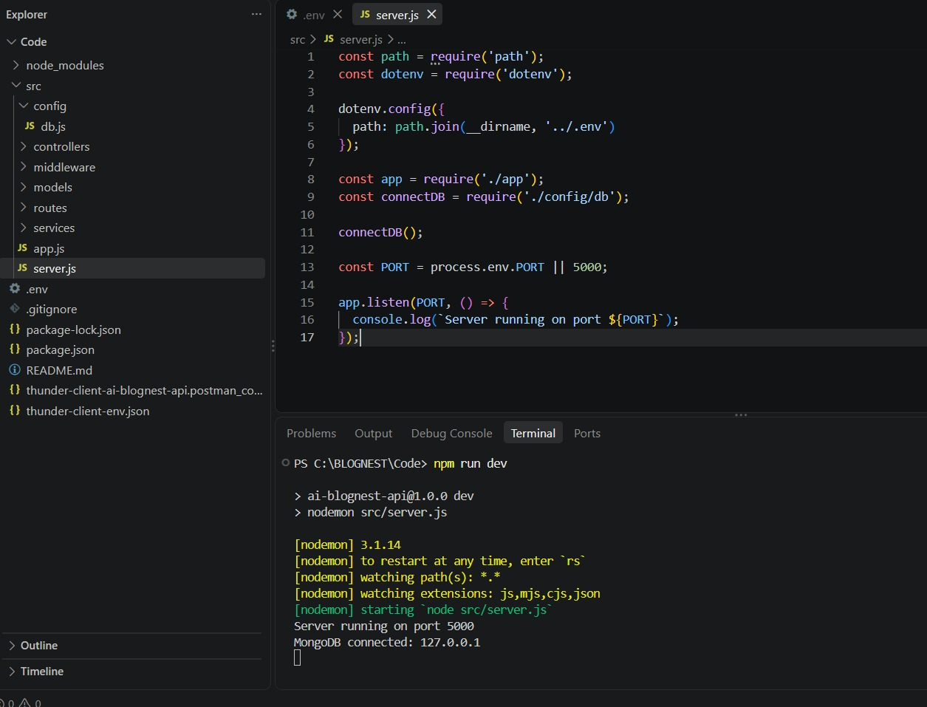
12.BACKEND DEVELOPMENT
Server.js

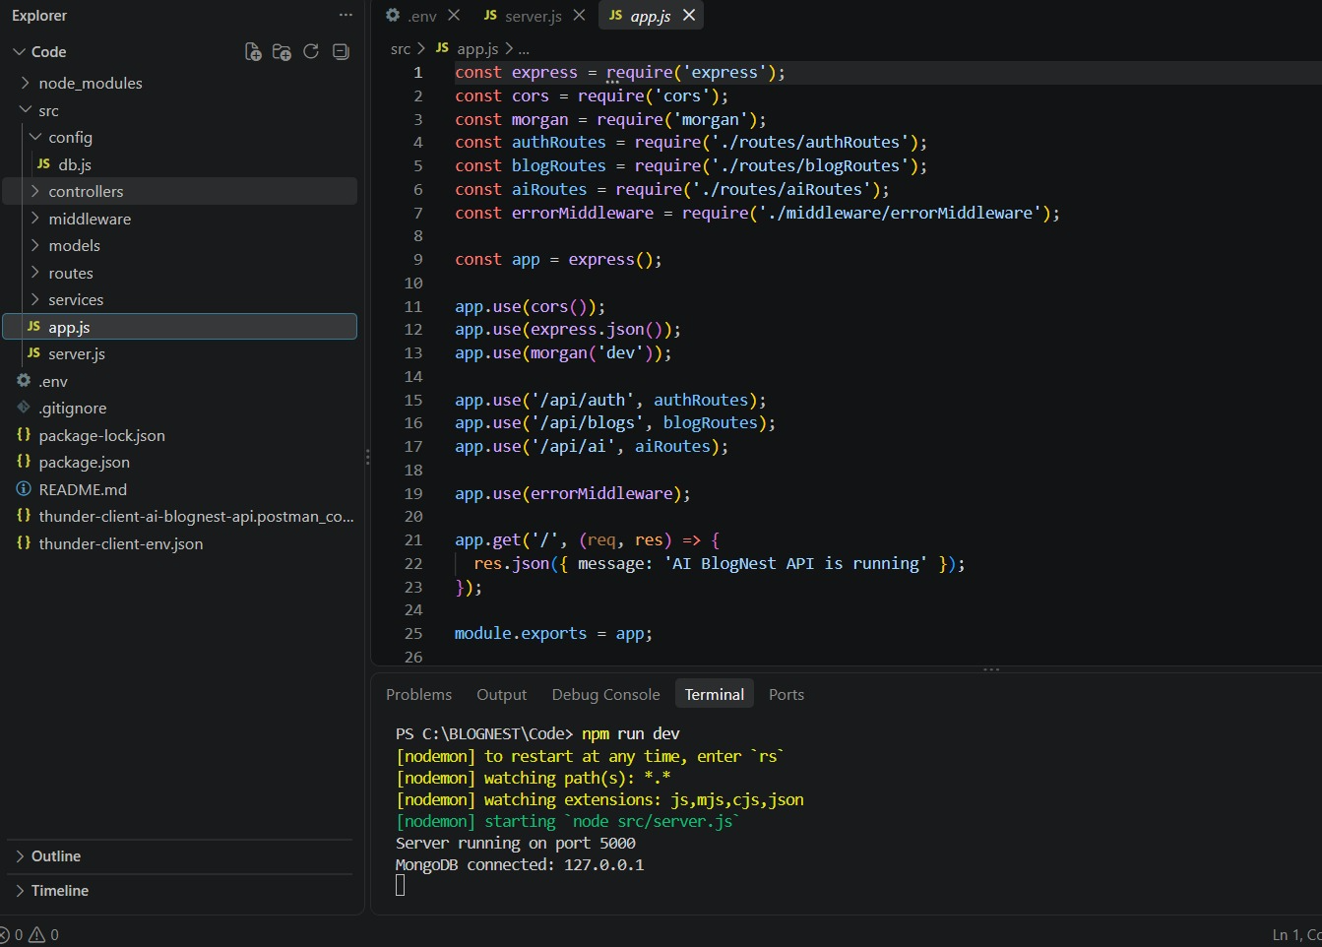

App.js
Database configuration
- Database connection:-
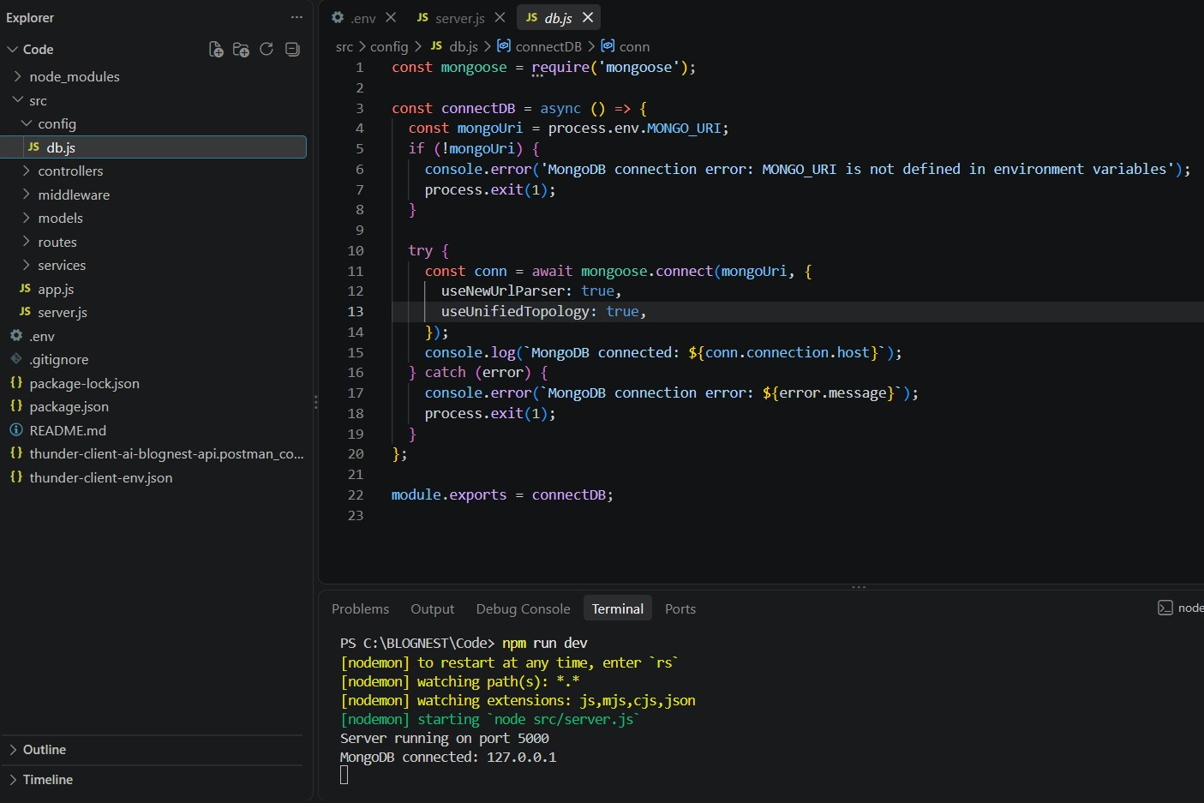

1. Configure MongoDB:
- Install Mongoose.
- In your Node.js project directory, run:
- npm install mongoose
- Create database connection.
- Create Schemas & Models.

Create Database connection:
Now, make sure the database is connected before performing any of the actions through the backend. The connection code looks similar to the one provided below

Mongoose Schema Definitions

1. Identity Resource Document Schema (schemas/userModel.js)
Enforces field criteria validations on incoming database creations:
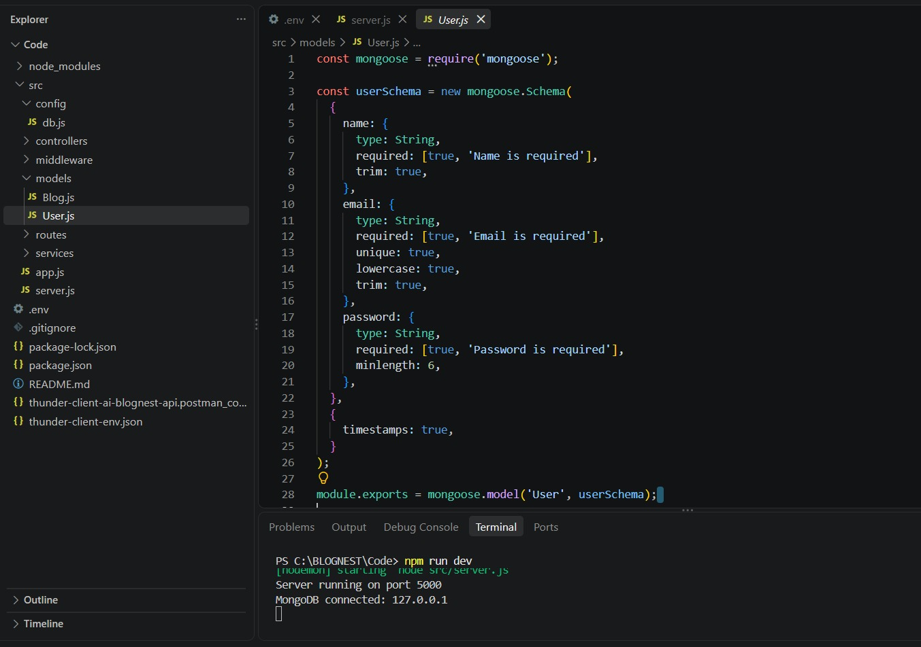

Project Executions:
· Install Postman or ThunderClient (VS Code extension).
· Start the backend server:
“npm start”
API Testing
User Registration
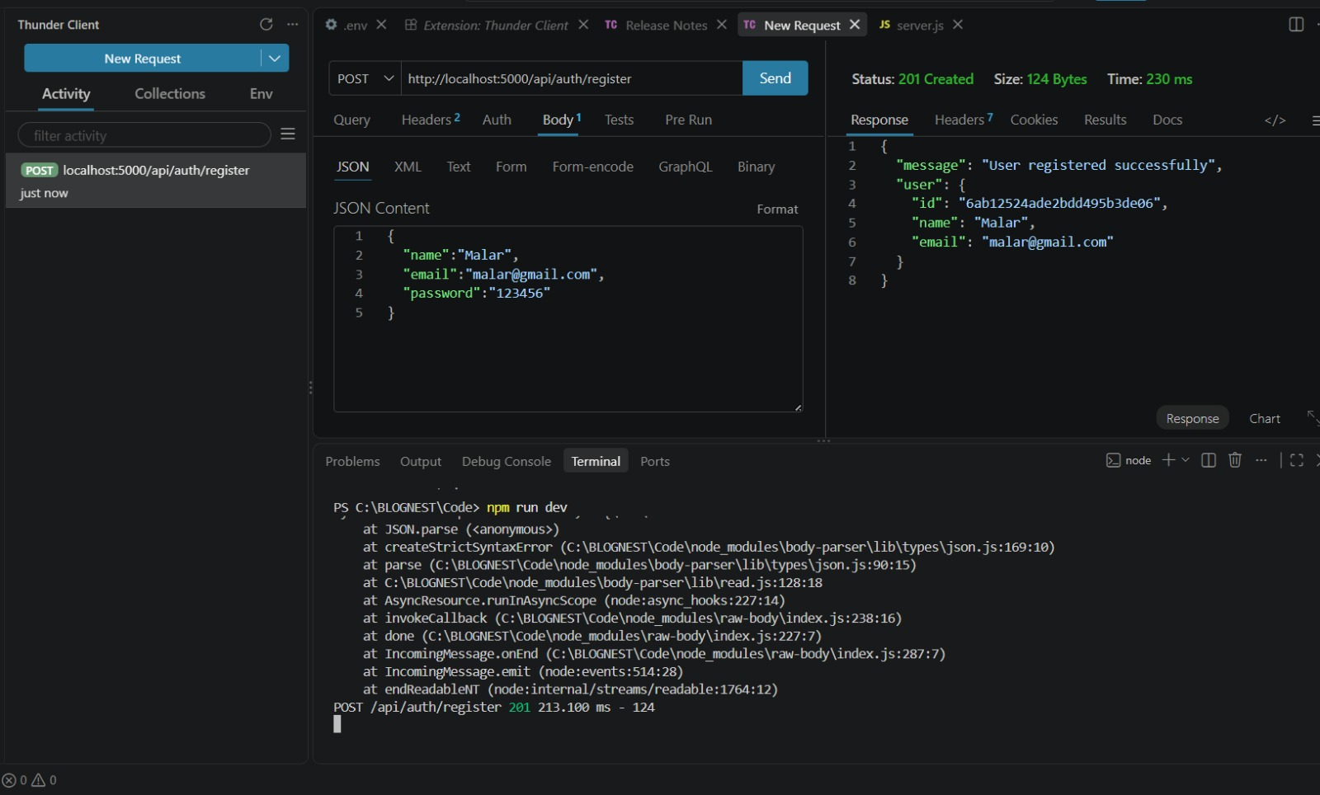
User Login
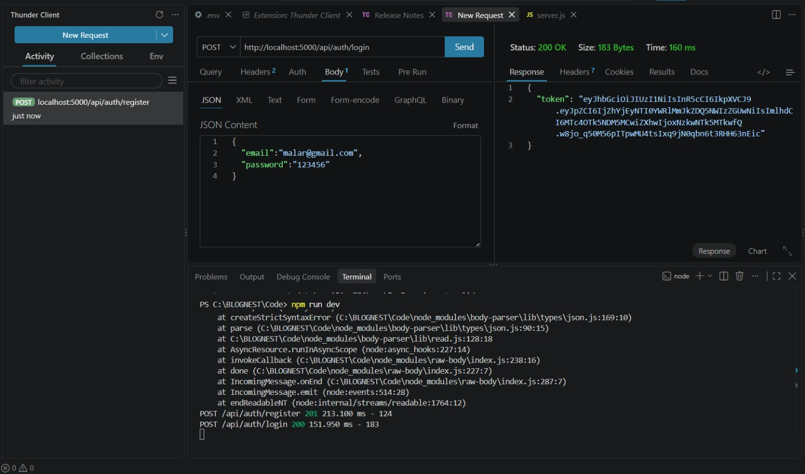

Create Blogs:

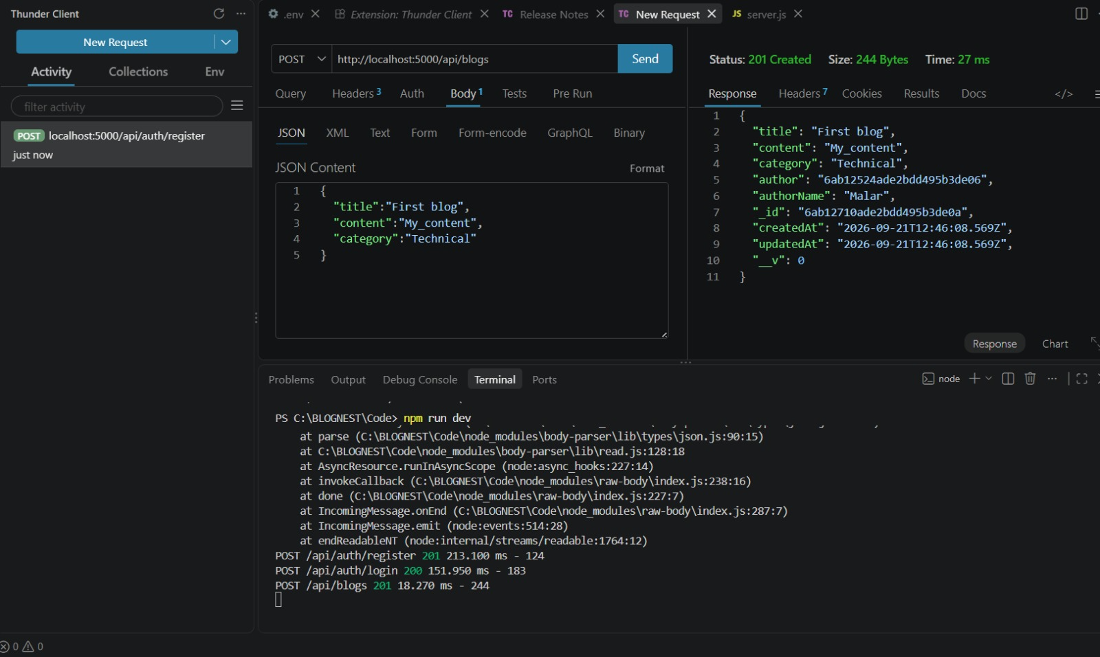

Fetch Blogs

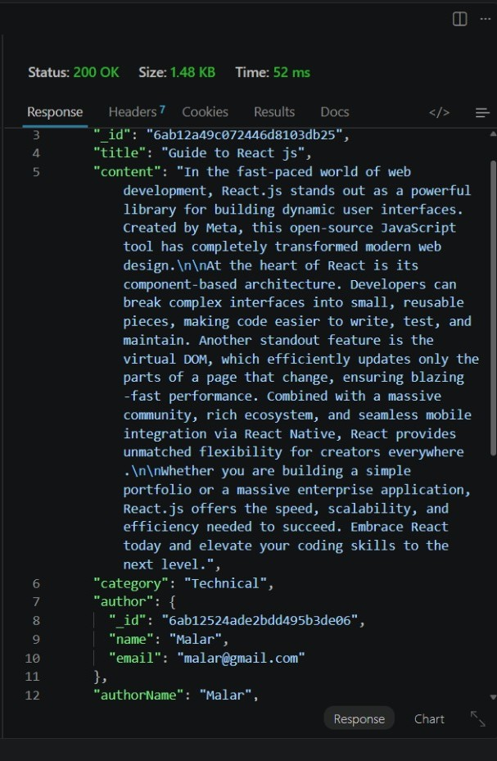

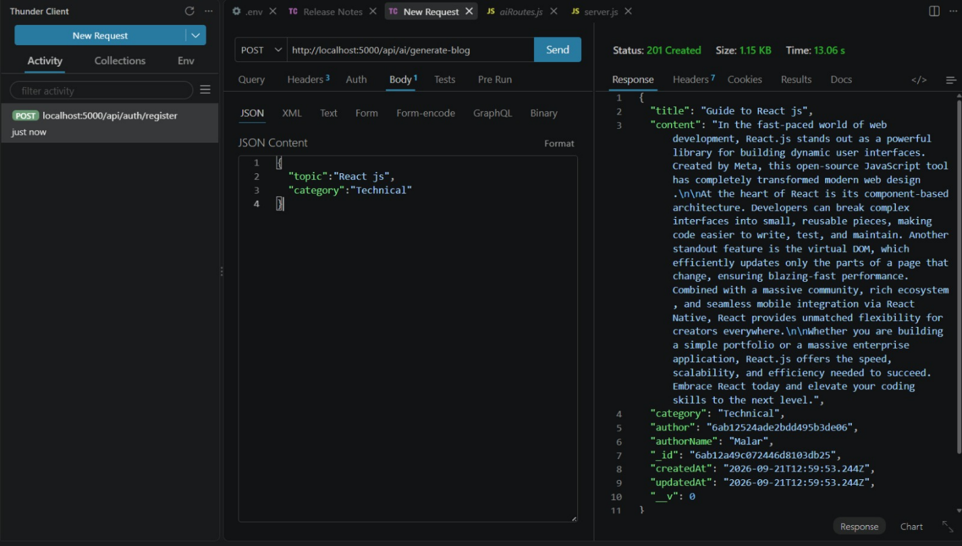
Generate AI blogs:
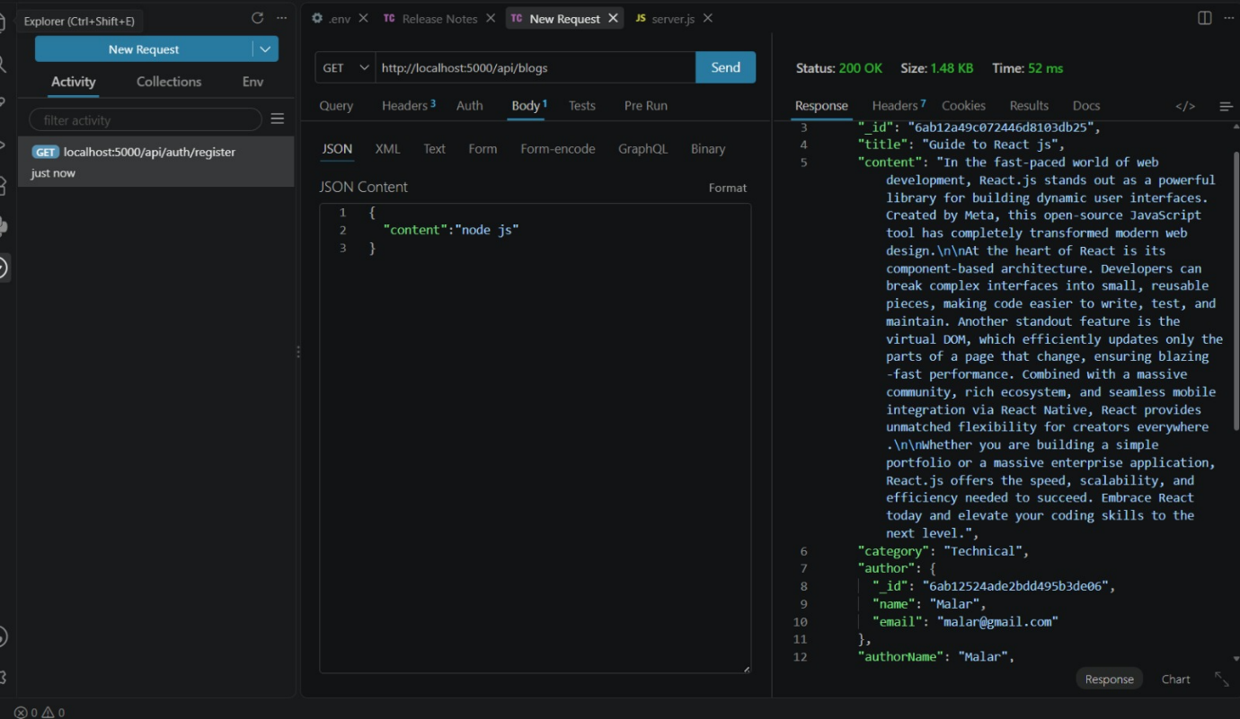
Summarise blog:

AI BlogNest is a modern AI-powered blogging backend that combines REST APIs, MongoDB, secure authentication, role-based access control and Generative AI. The system simplifies blog creation and management while providing intelligent tools for generating and summarizing content.
Its modular architecture allows the application to be extended with additional AI features, analytics, publishing workflows and frontend applications. The platform therefore provides a structured foundation for an intelligent content management system.
DEMO VIDEO: https://drive.google.com/drive/folders/1JMc9nArqm1vzRyi3obkHi2NbdusC_z6W?usp=drive_link
API TESTING VIDEO: https://drive.google.com/drive/folders/1JMc9nArqm1vzRyi3obkHi2NbdusC_z6W?usp=drive_link

